**Microprocessor Lab**

Laboratory Activity No. 1

**Familiarization with TinkerCAD**

|  |
| --- |
|  |

Score

*Submitted by:*

**LastName, FirstName MI.**

**<Schedule> / <Section>**

*Date Submitted*

**DD-MM-YYYY**

*Submitted to:*

**Engr. Maria Rizette H. Sayo**

1. Exercise

a. A process in Tinkercad where we can develop electronic circuits that can be quickly updated, modified and tested is called ________________.

b. In Tinkercad, ________________________ tests the working of the circuits and the components.

c. The device used to assemble and connect the various components is known as __________

d. In an electronic circuit with LED, the positive end of the circuit should be connected to

___________ and negative end should be connected to _______________ of the LED.

e. A ________________ is used to restrict the flow of current to electrical components

2. Label the following:



1. Anode and Cathode in a LED
2. Different parts of breadboard

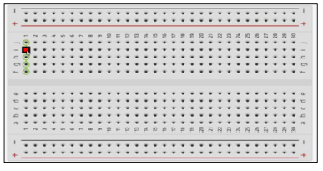

1. List the electronic components used in a circuit assembly